Name: Sally Phan
Year: 10

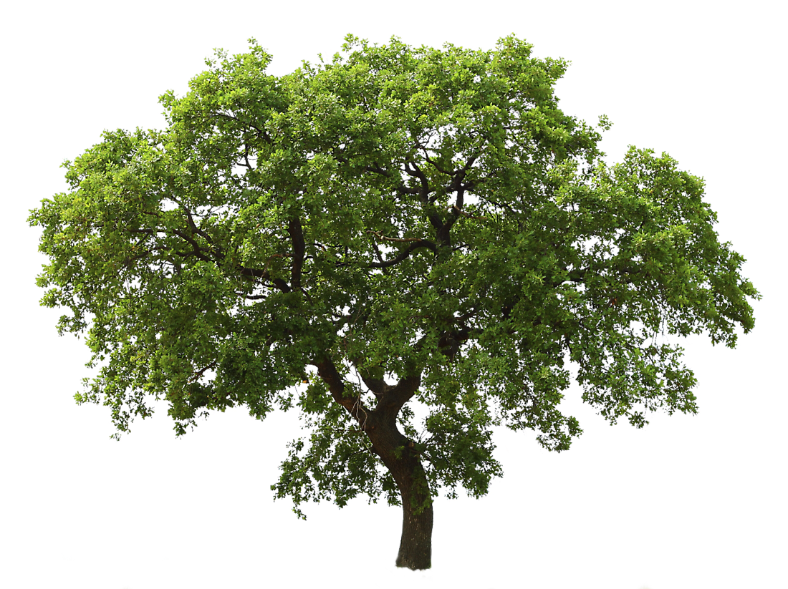
Double Exposure Effect – Model and Tree

Step 1:

- Open the model and the tree on Photoshop.
- Click the the model layer, select the Quick Selection Tool and select around her then Command + J to make the new layer.
- Click on the mother layer and make the new layer then fill it white colour. Delete the mother layer also put it under another layer.

Step 2:

- Go to the tree layer and Command + A, Command + C to copy the model layer.
- Command + T to select the tree and make it bigger. Select the Brush Tool and delete the part of the tree I do not need it.
- Click on the model layer and Command + T to select and make it smaller. Then change to the lighten.

Step 3:

- Press Shift + click on model layer to select her then click on the tree layer make the layer mask.

Step 4:

- Make a new layer and go to Solid colour select the dark colour and Exclusion.
- Then go to the Curves and used the graph for the light and dark of image.

Step 5:
- Save it in JPG.

Here we go:

